|  |  |
| --- | --- |
| **WC Logo.emf** | **Staff Report to the Weber County Commission**  *Weber County Planning Division* |
|  | |

****Synopsis****

****Application Information****

**Application Request:** Request for final approval of Parkside Phase 3 PRUD Subdivision, consisting of 16 lots.

**Type of Decision: Administrative**

**Agenda Date: Tuesday, June 27, 2023**

**Applicant: John Lewis, Owner**

**File Number:** UVP080922

****Property Information****

**Approximate Address:** 4843 Howe Dr., Eden, UT, 84310

**Project Area:** 4.184 acres

**Zoning:** Residential Estates (RE-15) Zone

**Existing Land Use:** Vacant

**Proposed Land Use:** Residential

**Parcel ID:** 22-006-0039

**Township, Range, Section:** T7N, R1E, Section 15 SW

****Adjacent Land Use****

**North:** Vacant/Mountainside PRUD site **South:** Parkside PRUD site

**East:** Parkside PRUD Phase 2B **West:** Vacant

****Staff Information****

**Report Presenter: Tammy Aydelotte**

**taydelotte@webercountyutah.gov**

**Report Reviewer: SB**

Applicable Land Use Codes

* Weber County Land Use Code Title 106 (Subdivisions)
* Weber County Land Use Code Title 108 (Natural Hazard Areas)
* Weber County Land Use Code Title 104 (Zones) Chapter 3 (RE-15 Zone)

Background and Summary

7/19/2016 – Conditional Use Permit request for The Bridges PRUD was approved.

10/27/2020 – Parkside PRUD Phase 2B recorded.

9/27/2022 – Preliminary approval granted by Ogden Valley Planning Commission.

10/25/2022 – Recommendation of final approval by Ogden Valley Planning Commission.

The applicant is requesting final approval of Parkside PRUD Phase 3 Subdivision in the RE-15 Zone. The proposed development consists of 16 lots with common area surrounding each lot.

The Parkside PRUD Phase 3 is part of the master planned community within the Wolf Creek Resort known as “The Bridges PRUD” which consists of a multi-phased development including six communities (364 units) with a variety of housing options and approximately 143 acres of open space. The proposed subdivision “Parkside PRUD Phase 3” is the final of three phases (72 units) in the Parkside community.

The proposed subdivision and lot configuration is in conformance with the current zoning, the approved PRUD and the Zoning Development Agreement Conceptual Land Use Plan as well as the applicable subdivision requirements as required in the LUC.

Analysis

*General Plan:* The proposal conforms to the Ogden Valley General Plan by encouraging development within the existing resort-related areas.

*Zoning:* The subject property is located in the Residential Estate Zone more particularly described as the RE-15 zone.

The purpose and intent of the RE-15 zone is identified in the LUC §104-3-1 as:

*“The major purpose of the RE-15 and RE-20 Zones is to provide and protect residential development at a low density in a semi-agricultural or rural environment. It is also to provide for certain rural amenities on larger minimum lots, in conjunction with the primary residential nature of the zone.”*

As part of the subdivision process, the proposal has been reviewed against the current subdivision ordinance in LUC §106, the PRUD ordinance in LUC §108-5, and the applicable standards in the RE-15 zone (LUC §104-3) to ensure that the regulations and standards have been adhered to. The proposed subdivisions, with the recommended conditions listed in this staff report, are in conformance with county code. The following is a brief synopsis of the review criteria and conformance with the LUC.

*Lot area, frontage/width and yard regulations*: The proposed subdivision is one of several phases in the Parkside community and has received conditional use approval for “The Bridges PRUD” development.

The purpose and intent of a Planned Residential Unit Development (PRUD) is intended to *“allow for diversification in the relationship of various uses and structures to their sites and to permit more flexibility of such sites and to encourage new and imaginative concepts in the design of neighborhood and housing projects in urbanizing areas”* (LUC§ 108-5-2).Parkside Phase 3 PRUD utilizes the allowed flexibility with lots ranging in size from 3,887 square feet to 6,778 square feet, and lot widths ranging in size from approximately 49 feet to approximately 75 feet. The various lot sizes will allow for the future lot owners to build custom homes ranging from 2000 to 4000 square feet. The approved minimum single family yard setbacks for the PRUD are:

Front Yard: 15 feet

Side Yard: 7.5 feet

Side; facing street on corner lot: 15 feet

Rear Yard: 20 feet

A condition of approval has been added to staff’s recommendation to ensure the minimum setback standards are added to the final subdivision Mylar.

*Ogden Valley Sensitive Lands Overlay Districts*: The development area falls within an area identified as an “Important Wildlife Habitat Area” that is part of the Ogden Valley Sensitive Lands Overlay Districts (LUC§ 104-28). A note providing adequate notice of the Important Wildlife Habitat area and the development standards that are required will be added to the final subdivision Mylar.

*Common Area:* The general requirements for a PRUD identify the need to preserve common open space. The proposed subdivision layout identifies common area surrounding all lots. The proposed common area for this phase follows the overall PRUD open space plan (exhibit C). This area will be required to be dedicated upon recording by one or more of the following methods:

(1) Dedication of the land as Public Park or parkway system;

(2) Granting to the county a permanent common open space easement on and over the said private open spaces to guarantee that the open spaces remain perpetually in access, parking, recreation or open space uses with ownership and maintenance being the responsibility of a home owners' association established with articles of association and bylaws which are satisfactory to the county; or

(3) Complying with the provisions of the Condominium Ownership Act, U.C.A. 1953, § 57-8-1 et seq., as amended, which provides for the payment of common expenses for the upkeep of common areas and facilities.

Any CC&R’s will need to comply with the provisions of the Condominium Ownership Act, U.C.A 1953, §57-8-1 et seq. per LUC §108-5-6(d)(3) for the preservation, maintenance and ownership of the common area. Prior to receiving final approval of the subdivisions from the County Commission, the applicant will need to provide to the County a copy of the proposed CC&R’s for review as well as a cash escrow to be held by Weber County for the proposed improvements including the amenities in the common area. The dedication language on the final plat will need to include language to grant ownership of the common area to the applicable ownership. A condition of approval has been added to ensure the final subdivision Mylar includes the correct dedication language for the common area located within the subdivision. A cost estimate for the improvements and a draft copy of any CC&R’s will also be required prior to receiving final approval from the County Commission.

*Natural Hazards Overlay Zone:* The proposed subdivision is located in a Zone “X” as determined by FEMA to be an area determined to be outside 500-year floodplain.

A geologic hazard study, as well as a geotech study are on file with the Weber County Planning Department. All recommendations outlined in the submitted reports shall be followed as further development occurs. A note shall be added to the plat to notify the future property owners of the geologic and geotechnical report on file with the Weber County Planning Division. A slope analysis has been submitted, and there are no lots with a slope of 25% or greater.

Upon recording the final subdivision Mylar a separate “Natural Hazards Disclosure” document will be required to be recorded to provide adequate notice of the geotechnical and geological recommendations to future property owners. A condition of approval has been added to staff’s recommendations to ensure that adequate notification is provided for future property owners regarding further development is noted on the subdivision Mylar.

*Culinary water, irrigation water and sanitary sewage disposal:* The applicant has provided a will-serve letter from the Wolf Creek Water and Sewer District for the culinary and irrigation water and sanitary sewer.

*Review Agencies:* The Weber County Surveyor’s Office, Weber County Engineering, and the Weber Fire District have reviewed the proposal and have provided the applicant with the additional items that will be required prior recording the final Mylar. A condition of approval has been made part of staff’s recommendations to ensure that any conditions of the applicable reviewing agencies are strictly adhered to.

*Additional design standards and requirements:* If the applicant would like to utilize the ability to have nightly rentals as an option allowed in the PRUD ordinance for the owner’s in the Parkside Phase 3 PRUD, a note will need to be added to the final Mylar to declare that the subdivision is approved for nightly rentals.

The applicant is proposing 60’ wide public rights of way throughout the proposed development, which will include 24” of rolled curb and gutter.

*Tax clearance:* The 2022 property taxes have been paid in full. The 2023 property taxes will be due in full on November 30, 2023.

Planning Commission Recommendation

The Ogden Valley Planning Commission forwarded a recommendation of final approval of Parkside PRUD Phase 3 Subdivision, consisting of 16 lots located at approximately 4843 Howe Dr., Eden, UT, 84310. This recommendation is subject to all review agency requirements and the following conditions:

1. In order to provide clear site standards, staff recommends adding the minimum yard setback standards on the final subdivision Mylar including the “Side; facing street on corner lot” setback.
2. A note providing adequate notice of the Important Wildlife Habitat area and the development standards that are required will be added to the final subdivision Mylar.
3. The dedication language on the final Mylar will need to include language to grant ownership of the common area to the applicable ownership.
4. A “Natural Hazards Disclosure” document will be required to be recorded to provide adequate notice of any geotechnical and geological recommendations for future property owners.
5. If the applicant desires, a note will be added to the final Mylar to provide notice of the approved nightly rental option.

This recommendation is based on the following findings:

1. The proposed subdivision conforms to the Ogden Valley General Plan
2. The proposed subdivision complies with applicable county ordinances

Exhibits

1. Subdivision Plat
2. Improvement Guarantee Agreement??

****Area Map****

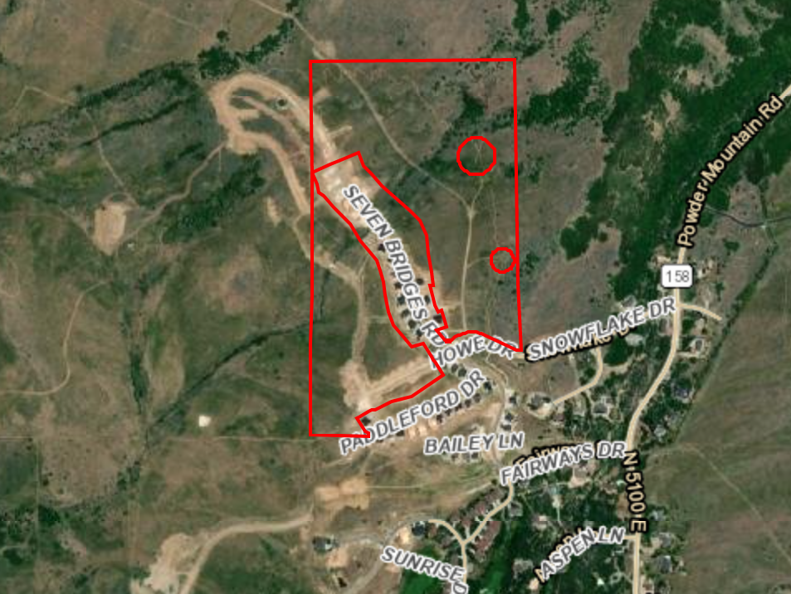

|  |
| --- |
|  |

****Exhibit A– Subdivision Plat****

